**Section 1, Step 19** – Take a Screenshot of the *entire* Terminal windows showing the IP packet you crafted using *scapy*.

**Section 1, Step 24** – Take a Screenshot of the *entire* Terminal windows showing the TCP protocol layer you crafted using *scapy*.

**Section 1, Step 25** – Take a Screenshot of the *entire* Terminal window showing the Ethernet layer for the packet you crafted using *scapy*.

**Section 2, Step 6** – Take a Screenshot of the *entire* Terminal window showing the result of the ICMP packet you sent using *scapy*.

**Section 2, Step 11** – Take a Screenshot of the *entire* Terminal window showing the result of the TCP SYN scan you sent using *scapy*.

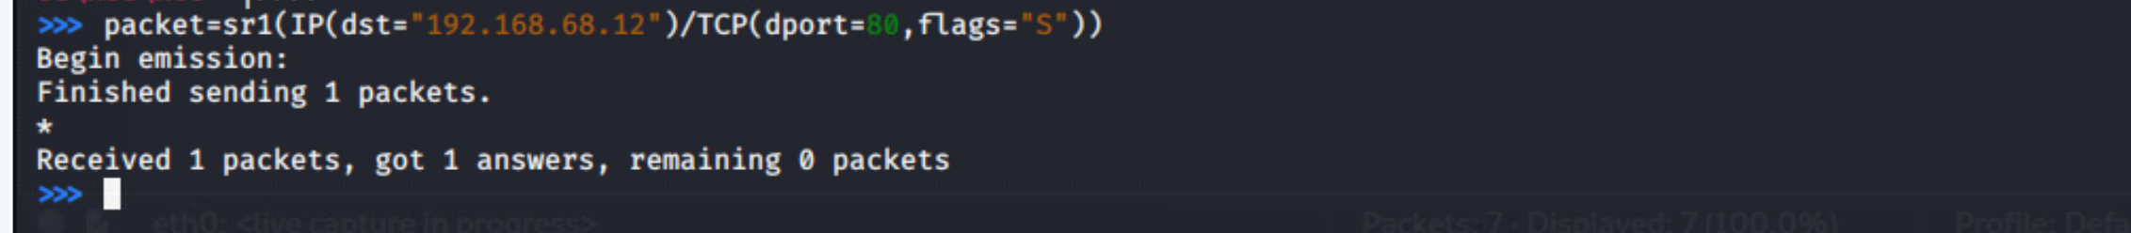**Section 2, Step 13** – Take a Screenshot of the *entire* Wireshark window showing the TCP SYN message being sent and received.

**Questions**

1. Now that you have used *scapy*, describe in your own words the purpose of the tool – and how it could be useful for an ethical hacker looking to attack devices on a network.
2. Using scapy from the command line might seem like an arduous method for an attacker to pull off network attacks like denial of service. Read <https://www.thepythoncode.com/article/syn-flooding-attack-using-scapy-in-python> to get an idea of how this tool can be used in a more efficient fashion (NOTE: You do not need to understand Python coding at this point – if you’re not familiar with it, look at the descriptions of what the code is doing)
   1. How was scapy used in this example to “take down” the router that was targeted?
3. It can difficult for a single machine to overwhelm another single machine unless the attacking machine is much more powerful and has a faster network connection.
   1. Using what you learned about malware/trojans/botnet and DDoS attacks in this class, formulate a plan to use scapy to overwhelm a network target or entire network – Summarize the steps of that plan here: